1. Waterproof Digital Temperature Sensor DS18B20

Operating voltage : **5V**

Input Current : **5 µA**

Additional Component : **Resistor 47.5k ohm¸Probe**

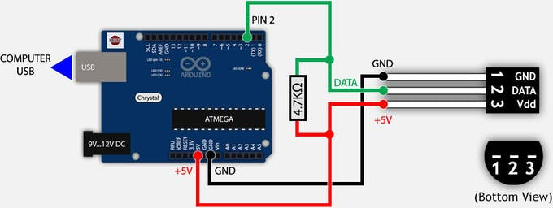

1. DFRobot Gravity: Analog pH meter V2

Operating voltage : **5V**

Input Current : **-**

Additional Component : -

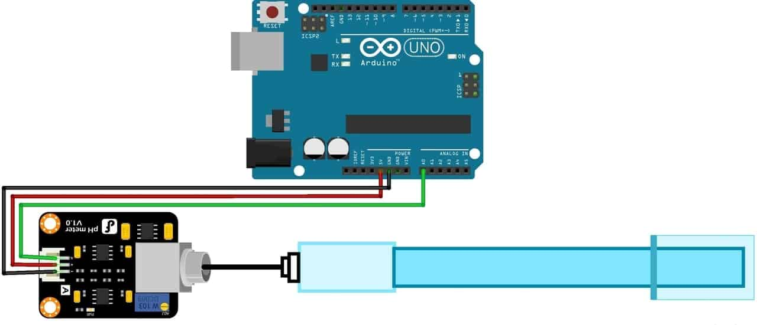

1. Arduino Mega 2560

Operating voltage : **5V**

Input Current : **20 mA (I/O) 50 mA (3.3V pin)**

Additional Component : **USB connector**

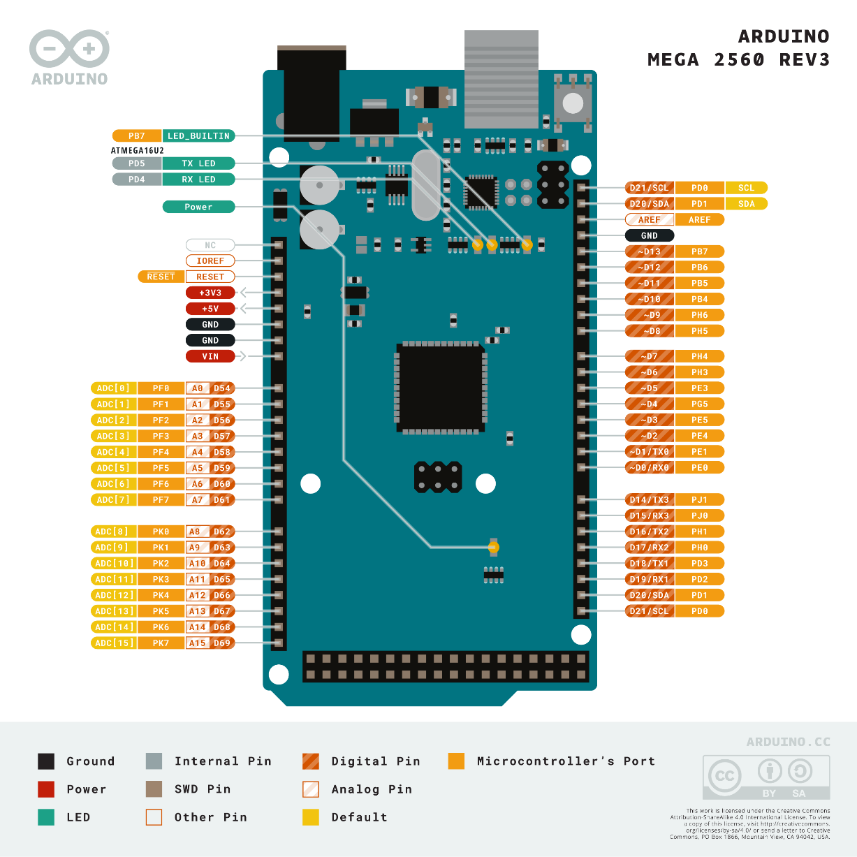

1. Raspberry Pi 4B

Operating voltage : **5.1 V**

Input Current : **3A**

Additional Component : **UBEC 3A 5V, MicroSD**

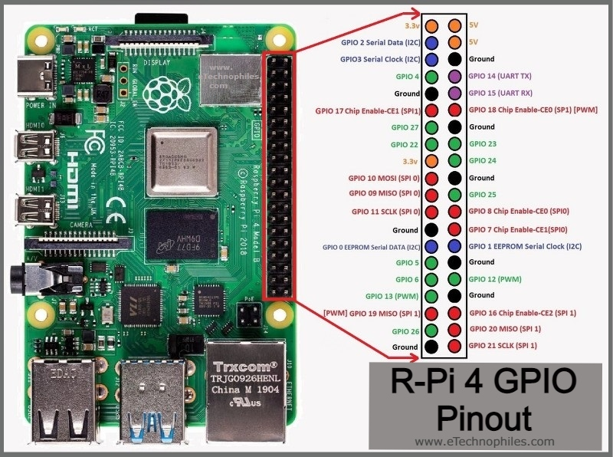

1. Webcam Logitech C270

Operating voltage : **‎240 V**

Input Current : -

Additional Component : -

1. DYS Brushless Motor G-Power D2822

Operating voltage : ‎**11.1 V**

Input Current : **30 A x 2 = 60 A**

Additional Component : ESC 30A

1. **Baterai LiPo 3s 5200mAh 11.1 V**

Additional Component : **Switch, T-Plug Cable**

1. PCB Double-Layer
2. Kabel Pelangi